NIPWG8-30.3

Paper for Consideration by NIPWG8

[Disccussion of the S-128 CNP Scope]

Submitted by: | Republic of Korea (KHOA)
Executive Summary: | This paper describes the discussions on S-128 CNP scope.
Related Documents: | NIPWG7-10.2 Items to be included into S-128 - Management of up-to-dateness  WENDWG11-05.2A INToGIS II update – S-128 – Towards INToGIS III for S-1xx Products  TSM8-5.2 S-128 Discussion
Related Projects: | INToGIS III Project

Introduction / Background

NIPWG has developed the S-128 CNP Product Specification in response to a requirement to produce a data product that can be used as an NPIO within an ECDIS. While KHOA has been working on the draft, there were discussions at WENDWG and TSM meetings if the current Product Specification is able to support the essential functionality of an IMO ECDIS and allow the member states to conform to the obligations to provide charts and publications for safe navigation. This paper describes the discussion progress and future plan of S-128 development.

Analysis/Discussion

Discussion on S-128 CNP
To consider the S-128 CNP to manage the up-to-dateness of S-101 ENC and all other relevant S-100 products, the S-128 data model includes the following as noted at NIPWG7:

- Publication date of the S-128 file itself
- Source of the S-128 file itself
- Information for each S-100 related product
  - Name of the S-100 product and “full/partial” related to that product
- Information for each data item
  - Edition number
  - Update number
  - Issue date

KHOA hosted a VTC to discuss the expansion of S-128 on January 26th, 2021 and discussed the topics below:
- Use of S-128 to manage up-to-dateness of nautical products for PSC purpose
- Use of S-128 for INToGIS III
- Alignment with S-100 5.0 and S-101 1.1.0

The meeting participants agreed that the draft S-128 Edition 1.0.0. is an appropriate standard for sharing the status and update level of nautical products. However, in order to find more uses of the product including PSC and other possibilities, use case study is necessary.

11th WENDWG VTC
KHOA presented the development of INToGIS III using S-128 at the WENDWG11 VTC (Feb 17-18, 2021). INToGIS II was developed to manage INT and ENC schemes. The system also provides 500 world ports, Global/Europe traffic density and other chart related contents. WENDWG agreed on the way forward to consider the subsequent development of INToGIS III, using S-128 CNP as far as possible, in order to allow HOs and other users to visualize S-1xx products coverage in the future.

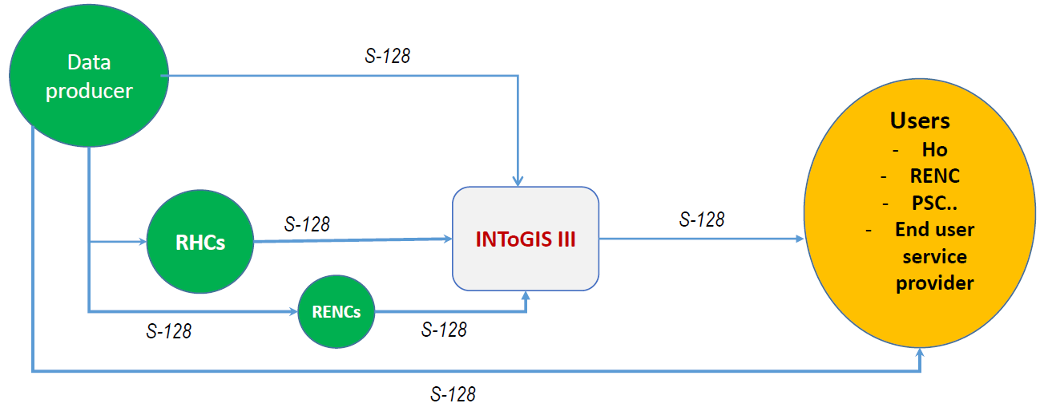
Figure 1. Overview of INToGIS III Project

8th TSM VTC
At TSM8, the needs of governance of the S-128 PS and use cases such as the up-to-dateness of the holding on-board in ECDIS were discussed. Some Hydrographic offices, RENC, OEM presented their contributions on sharing use cases from each of their own perspectives.
The use cases will be collected and investigated to expand the concept of S-128 and develop the current data model to a higher level of architecture for exchanging the catalogue of nautical products.
Further discussion items were presented such as single (RENC)/multi S-100 product service provider, and S-128 CNP as a catalogue replacing ENC status report.

Future plan
KHOA provided a template for use case study on S-128 CNP and requested S-100WG, WENDWG, NIPWG and TSM for contributions. All use cases will be investigated and applied to S-128 CNP Ed. 2.0.0. which will be aligned with S-100 Ed.5.0.0.

Conclusions

S-128 CNP can address all S-100 based products for the management of up-to-dateness. In order to meet the minimum requirements of the IMO for nautical charts and publications with S-100 products, it is necessary to discover all possible purposes with use case study to fill the gap in the overarching S-100 based products.

Action Required of NIPWG
The NIPWG is invited to:
- Note the progress of S-128 expansion discussion
- Take an action to support use case study and develop the next edition of S-128 in alignment with S-100 5.0.0.

